**Input Data Resource**

1. Read DRM/CDM **Raw Data** from RDF. Analytics Raw Data use snapshots as inputs (each engine has its own seed/utilization, go to CDM/DRM Documentation for further information) and generate outputs per flight
2. Normalize into **Daily Data**, changing flight date time into date time with the following feature informations:

|  |  |
| --- | --- |
| engine_id | engine ESN |
| Date |  |
| fleet |  |
| aircraft_id |  |
| engine_position |  |
| analytic_id | Analytic ID represents the combination of model and parts. It will uniquely identify the each analytic. |
| value | Value for each analytic. |
| cycles | daily accumulative cycle for each part |
| JumpFlag/slope_change | An indicator which indicates slope change on that day and after |

Daily Data

|  |  |  |  |  |  |  |  |  |
| --- | --- | --- | --- | --- | --- | --- | --- | --- |
| flight_date | fleet | aircraft_id | engine_id | engine_  position | analytic_id | value | cycles | slope_change |
| 9/19/14 | UAE | A6-ECS | 906140 | 2 | 1 | 2.03481366 | 978.5014 | FALSE |
| 9/19/14 | UAE | A6-ECS | 906140 | 2 | 1 | 2.03710422 | 979.4657 | FALSE |
| 9/20/14 | UAE | A6-ECS | 906140 | 2 | 1 | 2.04786795 | 980.43 | FALSE |
| 9/21/14 | UAE | A6-ECS | 906140 | 2 | 1 | 2.04960677 | 981.3942 | FALSE |
| 9/21/14 | UAE | A6-ECS | 906140 | 2 | 1 | 2.09576534 | 982.3585 | TRUE |
| 9/22/14 | UAE | A6-ECS | 906140 | 2 | 1 | 2.10536128 | 983.3228 | TRUE |
| 9/23/14 | UAE | A6-ECS | 906140 | 2 | 1 | 2.15728244 | 984.2871 | TRUE |
| 9/23/14 | UAE | A6-ECS | 906140 | 2 | 1 | 2.16421888 | 985.2514 | TRUE |
| 9/24/14 | UAE | A6-ECS | 906140 | 2 | 1 | 2.24051315 | 986.2157 | TRUE |
| 9/24/14 | UAE | A6-ECS | 906140 | 2 | 1 | 2.24187688 | 987.18 | TRUE |
| 9/25/14 | UAE | A6-ECS | 906140 | 2 | 1 | 2.29076135 | 988.1442 | TRUE |
| 9/26/14 | UAE | A6-ECS | 906140 | 2 | 1 | 2.30514121 | 989.1085 | TRUE |
| 9/26/14 | UAE | A6-ECS | 906140 | 2 | 1 | 2.35907078 | 990.0728 | TRUE |
| 9/26/14 | UAE | A6-ECS | 906140 | 2 | 1 | 2.36949525 | 991.0371 | TRUE |

1. Aggregate into **Forecast Data** which contains forecast outputs, one record per analytic/engine. The following is a description of each column of the forecast report:

* report_date: Actual ABM report date
* fleet: Customer code
* engine_id: Engine serial number
* analytic_id: Analytic identifier, this key will be used to add analytic configuration
* algorithm: Algorithm name (e.g., Forecast, Probabilistic Forecast, Aggregator)
* cycles: Current component cycles
* value: Analytic value at last cycle
* interception_cycles: Cycles at analytic limit/threshold
* analytic_limit: Analytic threshold
* inspection_cycles: Number of cycles before hitting the analytic limit

Forecast Data:

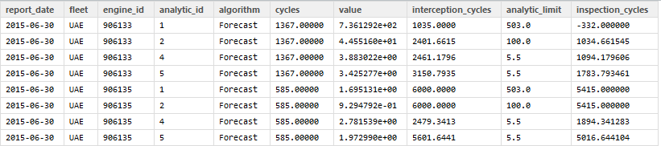

1. **Configurations Data** containing configuration parameters:

|  |  |
| --- | --- |
| analytic_id | Analytic ID represents the combination of model and parts. It will uniquely identify the each analytic. |
| analytic | Type of the analytic methodology i.e., Cumulative Damage Model (CDM), Distress Ranking Model (DRM), Service Bulletin (SB) |
| module | module Name, e.g., High Pressure Turbine (HPT) |
| component | Part name, e.g., Hardware/component name Blades, N5, N500 |
| output_name | Output name of the analytic, e.g., Metal Loss, Time at Temperature (TaT), Blades Distress Ranking (BDR), Shrouds Distress Ranking (SDR), Shrouds Distress Ranking – Oxidation (SDRO), Shrouds Distress Ranking – Corrosion (SDRC) |
| threshold | Inspection threshold of each analytic |
| offset | Apply offset or not |
| maxcycles | Maximal cycles allowed before inspection |
| rollingwindow | Apply rolling window or not |
| trainingwindow | training window size |
| fitorder | order of regression of aggregator |

Configurations Data:

